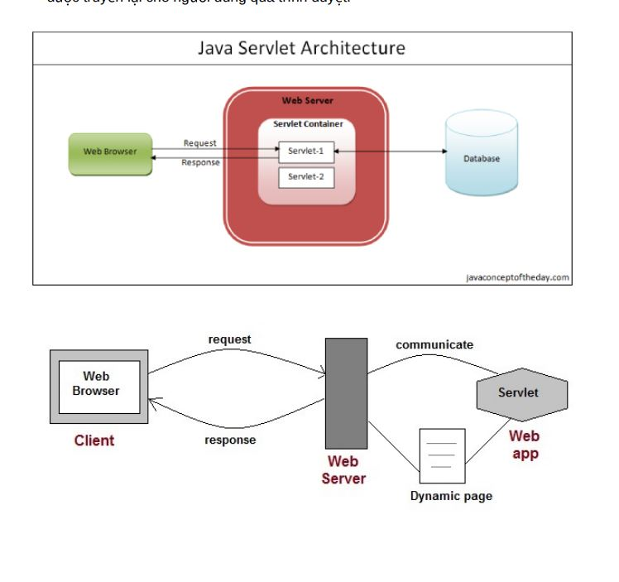
I) HTTP request, response and java webApp overview
- Servlet is a small java program run on a WebServer to help build dynamic web pages
Request header example:
GET / HTTP/1.1
Host: www.facebook.com
Accept: text/html,application/xhtml+xml,application/xml;q=0.9,image/webp,*/*;q=0.8
Accept-Charset: ISO-8859-1,utf-8;q=0.7,*;q=0.3
Connection: keep-alive
Cookie: sb=xyz123; datr=abc456; fr=0a1b2c3d4e5f6g7h8i9j
Referer: https://www.google.com/
If-Modified-Since: Wed, 21 Oct 2020 07:28:00 GMT
User-Agent: Mozilla/5.0 (Windows NT 10.0; Win64; x64) AppleWebKit/537.36 (KHTML, like Gecko) Chrome/91.0.4472.124 Safari/537.36
- It can also send a number of headers:
  - Accept The MIME types the browser prefers.
  - Accept-Charset The character set the browser expects.
  - Content-Length (for POST messages, how much data is attached)
  - Connection Use persistent connection? If a servlet gets a Keep-Alive.
  - Cookie (one of the most important headers)
  - Host (host and port as listed in the original URL)
  - If-Modified-Since (only return documents newer than this)
  - Referer (the URL of the page containing the link the user followed to get to current page)

- HTTP 1.1 defines the following request methods(7):
  - GET - retrieves the resource identified by the request URL.
  - HEAD - returns the headers identified by the request URL.
  - POST - sends data of unlimited length to the web server.
  - PUT - stores a resource under the request URL.
  - DELETE - removes the resource identified by the request URL.
  - OPTIONS - returns the HTTP methods the server supports.
  - TRACE - returns the header fields sent with the TRACE request.

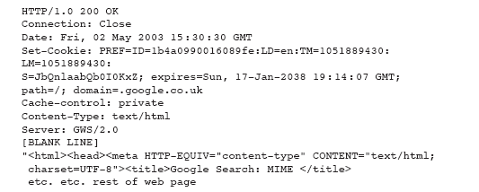
RESPONSE

Some commonly used status codes include:
  - 404 - indicates that the requested resource is not available.
  - 401 - indicates that the request requires HTTP authentication.
  - 500 - indicates an error inside the HTTP server which prevented it from fulfilling the request.
  - 503 - indicates that the HTTP server is temporarily overloaded, and unable to handle the request.
- Switching Protocols
Server will comply with Upgrade header and change to different protocol. (New in HTTP 1.1)
- OK
Everything's fine; document follows for GET and POST requests. This is the default for servlets; if you don't use setStatus, you'll get this.
- Created
Server created a document; the Location header indicates its URL.
202 Accepted
Request is being acted upon, but processing is not completed.
203 Non-Authoritative Information
Document is being returned normally, but some of the response headers might be incorrect since a document copy is being used.

Construct the file and directory structure of a Web Application that may contain:
  - static content,
  - JSP pages,
  - servlet classes,
  - the deployment descriptor (web.xml)
  - tag libraries,
  - JAR files and Java class files;
  - 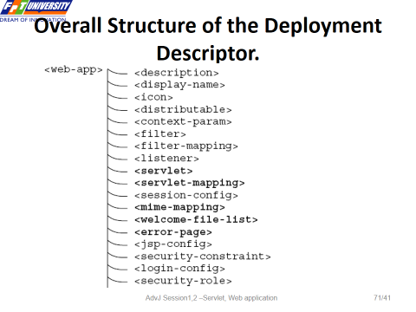

II, JSP

How JSP work:
- Request: User requests a JSP page.
- Translation: JSP file is translated into a Java servlet source file. (.java)
- Compilation: Java servlet source file is compiled into a servlet class. (.class)
- Loading: Compiled servlet class is loaded into memory.
- Execution: Servlet's service method generates and sends the response.
- Subsequent Requests: For subsequent requests, the already compiled servlet class (.class file) is used unless the JSP file is modified. If modified, the process from translation to execution is repeated.
JSP predefined-variable: ( implicit objects)
- request – Object of HttpServletRequest (request parameters, HTTP headers, cookies, session)
- response – Object of HttpServletResponse
- exception – Dùng để xử lí lỗi , chỉ có trong errorPage = “true”
- out - Object of PrintWriter buffered version JspWriter
- session - Object of HttpSession asociated with the requests
- application - Object of ServletContext shared by all servlets in the engine
- config - Object of ServletConfig
- pageContext - giúp truy cập & quản lý toàn bộ phạm vi dữ liệu (page, request, session, application)
✔ Dùng pageContext khi cần:
- Tìm biến từ nhiều phạm vi (findAttribute())
- Chuyển trang dễ dàng (pageContext.forward()) , ko cần RequestDispatcher
- Lấy request, response, servletContext nhanh chóng
- Lưu trữ dữ liệu chỉ trong trang hiện tại

- page – variable synonym for this object (page thực chất là Servlet mà JSP được biên dịch thành.)
------------------------------------------------------------
Các loại phần tử chính của JSP:
1. JSP Directives (Cấu hình JSP)
- Page <%@ page attributeName=“value" import=”java.io.*” %>
- Import <%@ include file=“relativeURL " %>
- taglib <%@ uri = … prefix = … %> (reference to a tag library)

2. JSP Scripting Elements(Chứa mã Java thuần trong JSP):
  - declaration <%! %> (declare a variable or method) , (Khai báo biến hoặc phương thức Java)
  - expression <%= %> ( the value is converted to string ), (Xuất giá trị ra HTML)
  - scriptlet <% %> (When this JSP code is translated into a servlet, it will be placed inside the _jspService(HttpServletRequest request, HttpServletResponse response) method ) (giống php: để Viết code Java bên trong JSP)

3. Standard Actions (các thẻ XML-like bắt đầu bằng <jsp:..>)
( thay thế scripting element để thực thi công việc 1 cách gọn gàng):

JSP Action Tags | Description
jsp:forward | forwards the request and response to another resource.
jsp:include | includes another resource.
jsp:useBean | creates or locates bean object.
jsp:setProperty | sets the value of property in bean object.
jsp:getProperty | prints the value of property of the bean.
jsp:plugin | embeds another components such as applet.
jsp:param | sets the parameter value. It is used in forward and include mostly.
jsp:fallback | can be used to print the message if plugin is working. It is used in jsp:plugin.
----------------------------------------------------------------
<jsp:include page="includedPage.jsp" /> vs <%@ include file=“ includedPage.jsp " %> (include directive) khác nhau như sau:
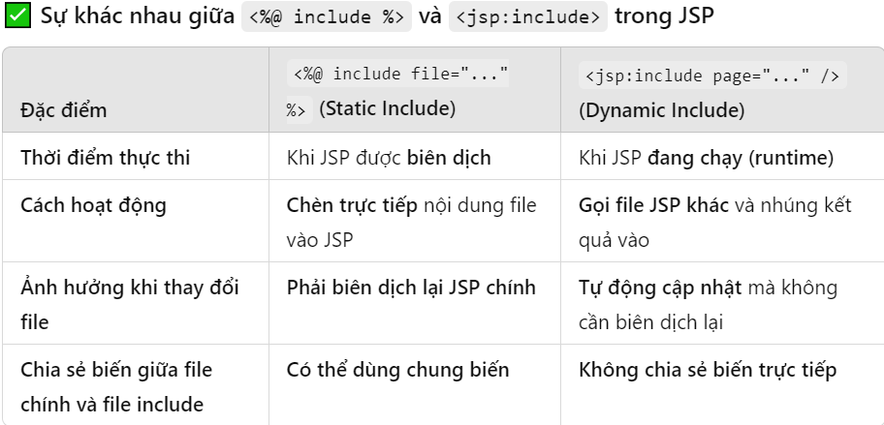(cụ thể là thay đổi file include)
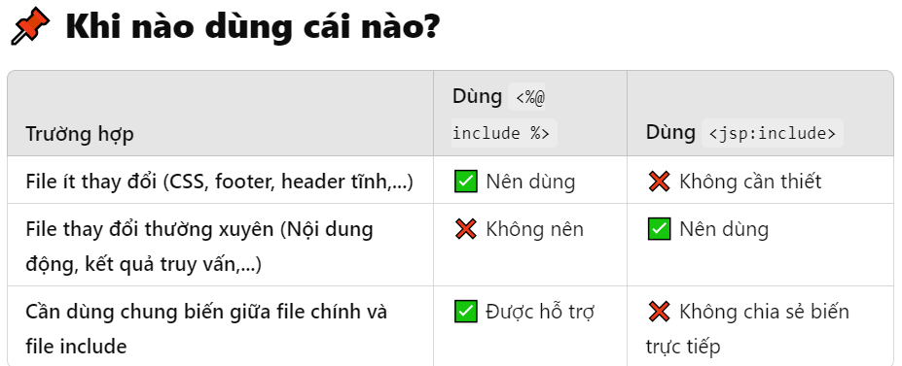
---------------------------------------------------------------------------
COMBO hủy diệt : JSTL + EL
1. EL
- Có sẵn trong JSP 2.0+, không cần thêm thư viện.
- Dùng để thay thế JSP Expression (<%= ... %>).
- Danh sách các biến có sẵn trong EL và ví dụ:

-----------------------------------------------------------------------------------------------
III) Create Custom tag

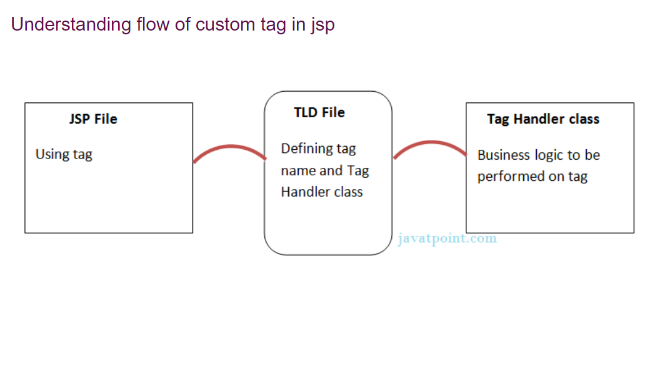
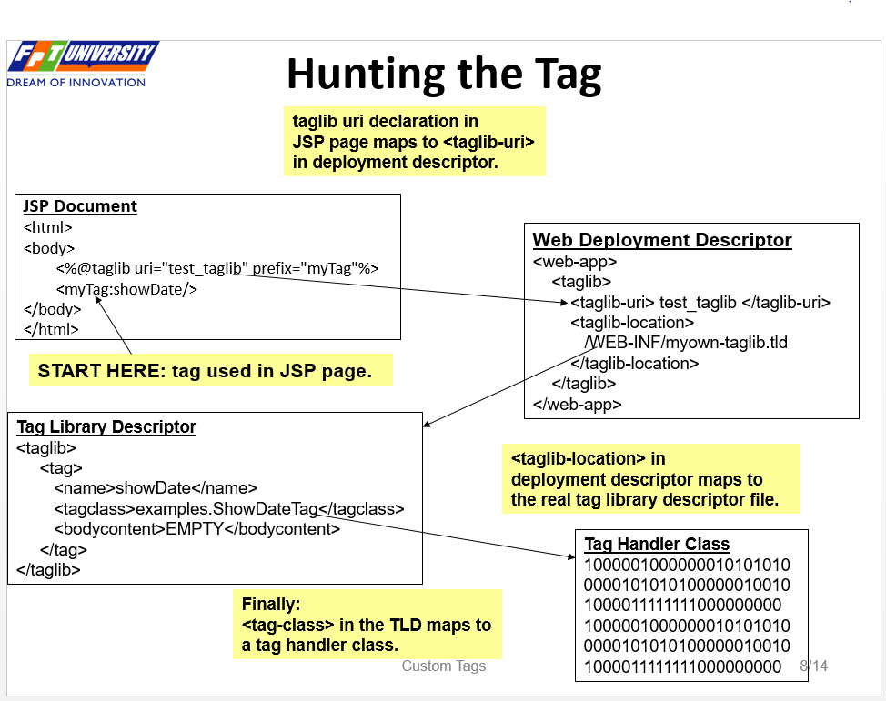

JavaBean là các class Java thuần, dùng để thể hiện các thực thể trong các chương trình Java.

Một lớp JavaBean sẽ có 3 đặc điểm như sau về mặt cú pháp:
1. Là một public class
2. Có các thuộc tính private
3. Ứng với mỗi thuộc tính, lớp sẽ cung cấp một cặp phương thức setter / getter để truy cập và thao tác với giá trị của từng thuộc tính.

